A meeting in the PGD Lab
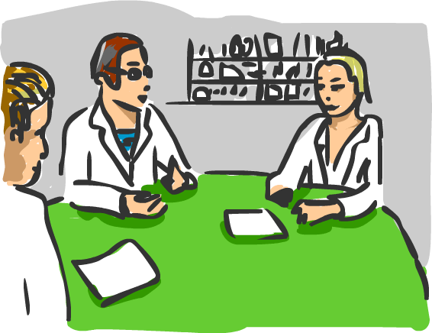
- Choose the character everyone will play.
- Read the scripted play out together or in front of the class.
- Read through the role play section of the play and discuss the answers each character might give to the question. If necessary, take notes. There are no right or wrong answers!
- Read the whole play through, both sections, answering ‘in character’ in the role play section.

Characters
  Kevin – Research technician, ambitious and eager to get on in the lab. |   Dr Liz Brown – Lab leader, very successful in her field.
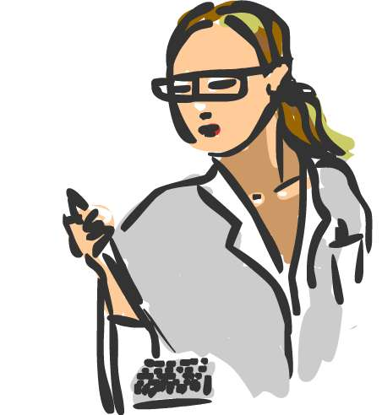  Jem– PhD scientist, new to the lab, takes a thoughtful approach. | 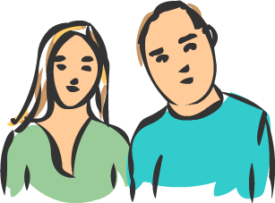  Larry and June Shannon parents of Sally.  They have been in and out of hospitals with their daughter since she was born. They don’t see why anyone would object to their requests to use PGD to save her life.

Section 1 – The Script
The research team are gathered in the lab. There are some difficult decisions to be made today. Dr. Liz Brown begins the meeting

Dr Liz Brown Good morning everyone, and thanks to you all for attending today’s meeting. I would like to introduce you to Larry and June Shannon (indicates to them).

Larry and June have been married for six years. They have a 4-year-old daughter, Sally, who has been diagnosed with Diamond Blackfan anaemia. Larry, would you like to take up the story?

Larry Sally was born without any thumbs, and she didn’t seem quite ‘right’ from day one, though we didn’t know what the problem was at first. When she was two months old we found out that she had Diamond Blackfan anaemia and that her bone marrow was failing. It was not producing enough red blood cells. She has problems with her kidneys, and her immune system. … its been… its been awful (looks to June) . She needs a lot of care, special drugs, trips to hospital for transfusions and she spends most nights with a needle in her arm, attached to a machine to clean the iron from her blood. Some people only have Diamond Blackfan anaemia mildly and they are not very ill, but Sally has it very severely.

June Sally’s symptoms have started getting worse… and we’ve been told that she needs a bone marrow transplant or she will eventually die (sighs deeply).

She needs a transplant from someone who is a good genetic match. We got tested, but we don’t either of us match Sally closely enough, and so far no one can find a good match anywhere else. We’re getting desperate…. (in emotional voice) we don’t want Sally to die… she deserves all the chances we can give her.

Kevin I’m really sorry to hear the problems you and Sally are living through.

Dr Liz Brown Larry and June are thinking of having another child and they have asked us about using our PGD technique. They would like to use the fertility treatment IVF to conceive their next child and use PGD to make sure that the new baby is a good tissue match for Sally.

After the new baby was born, the umbilical cord, instead of being thrown away, could be kept and used to provide the transplant stem cells for Sally; there is a 95% chance that it would cure her.

It is important to realise that we would only use the umbilical cord from the new baby, the law would prevent asking the baby to donate anything else later on if the stem cell transplant fails. Children are not allowed to be donors in this country.

Kevin Well I say let’s go ahead with it if it will help cure Sally.

Jem I don’t know. (to June) Are you uncomfortable with selecting a baby to save its sisters life.?

June If Sally cannot have a stem cell transplant, we can keep looking for a bone marrow donor and carry on with her drugs and the blood transfusions. But even with these, the chances are that Sally will die in the next two years.

Larry Dr Brown, I have a question about the embryos PGD creates. My mother is a Catholic, and her priest has told her that the church has objections to the use of IVF and PGD. He says these techniques waste embryos, which are precious human life. Is that true?

Dr Liz Brown Well, there are some religious and Pro-Life groups that are opposed to IVF and PGD. Certainly during PGD we do create more embryos than we use, and we do discard some embryos. We only use the healthy embryos and in this case, only those that were also a tissue match for Sally.

Many parents find that concerns they have about discarding such early embryos – they have around 8 cells and only are 3 days old – are often outweighed by their desire to save their sick child. You will have to search your own beliefs and make the choice that is right for you and your family.

Section 2 – Role play

Dr Liz Brown What if we do this, and we treat Sally, but the treatment fails, or worse, leads to Sally dying as can happen in about 5% of cases? How will you feel about your new baby then? Would you resent the new baby?

June

Jem If the treatment failed, and Sally lived but was still ill, would you secretly wish you could use the new baby as a donor of some sort for Sally? Maybe you would be frustrated that you the law does not allow you to use the new baby in this way?

Larry

June Can I just remind you all what might happen if we don't do this PGD? The chances are that Sally will die in the next two years, we mustn't forget that?

Dr Brown, can I ask if you agree with the use of PGD in our case, to produce a 'saviour sibling' for Sally?

Dr Liz Brown

Larry Kevin, you seem enthusiastic, but are there some people who might object to our request?

Kevin

Kevin Jem, I can tell you are not sure, if this was your own parents trying to save you, what advice would you give them?

Jem

Dr Liz Brown There are some serious issues to think about, and of course we would have to get this procedure approved by the right authority. So can I ask for a show of hands as to whether you each think we should proceed or not?

Those in favour of using PGD to select a tissue match for Sally, raise your hand (count votes) and those against , raise your hand
(Dr Brown votes too, this question could be put to the whole class/audience)

So we will/will not (as voted) proceed with PGD for saviour sibling.

I wonder what other people outside this lab will think of our decision?
END

